Dia de los Muertos is an annual celebration throughout Mexico where citizens fondly remember family members who have passed. During this multi-day event, friends, families, and communities gather to celebrate the lives of loved ones by creating altars, or ofrendas that are designed to encourage souls to visit. Typically, ofrendas contain the favorite food and beverages of the loved one, nourishment for the long journey from the after-life, as well as bright candles and flowers that light the way.

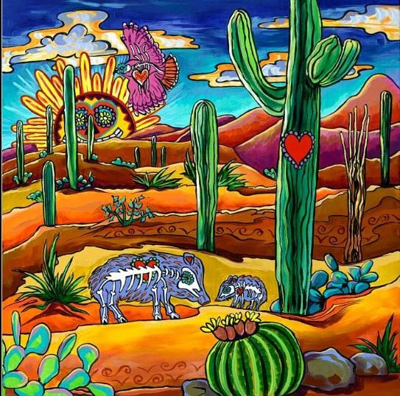

**Ofrenda Design Packet**

**2022**

Each year, the College of Education and Social Sciences hosts a Celebration of Life, starting with the setup of university and community ofrendas, and concluding with a festive gala. This annual event serves as a fundraiser for the College of Education and Social Sciences at West Texas A&M University and all proceeds are directed towards scholarships and/or student support.

This packet contains information for university students who are designing ofrendas as a requirement or as extra credit in one of their College of Education and Social Sciences courses.

# **Important Dates:**

|  |  |  |
| --- | --- | --- |
| Monday, October 24th | 5:00 pm Deadline for Registration | Registration Link:  <https://forms.gle/kCwFQ5kmJBa6Tdwu7> |
| Saturday, October 29th | 9:00 am—5:00 pm | Set up ofrenda at the Panhandle Plains Historical Museum. Tables provided. T-shirts available for purchase-$10. Tables are issued on a first-come first-served basis. |
| Tuesday-Friday, November 1-4, 2022 | 9:00 am—5:00 pm | Local Schools and groups will tour the ofrenda in the museum. |
| Wednesday, November 3rd | 12:00 pm | Adjudication and Trophy Presentation in the categories of:  Grand Champion  2nd place  3rd place  Hispanic Heritage (reflecting traditional culture)  Most Creative  Community Champion (non-WTAMU participant)  People’s Choice |
| Friday, November 4th  This event is TBD and pending | 5:00—7:00 pm | TBD:  Reception at the Panhandle Plains Historic Museum featuring Mariachi band. Cash bar. |
| Saturday, November 5th | 9:00 am—noon | Ofrenda cleanup at the PPHM |

# **Ofrenda Requirements:**

* Each ofrenda will be provided one table.
* Each ofrenda must include a **written description** of the ofrenda, its significance to the participant(s) and the name of the participant(s).
* Participants may not use any flame or electricity. LED, battery-powered lights are recommended.
* Participants may not attach any items to the walls, floor, or displays in the PPHM.
* Participants must not incorporate any substances that will damage carpeting, walls, or displays in the PPHM. (You will be held liable for any damage.)
* All food items must be wrapped in plastic. NO FRESH FRUIT.
* All drinks must be in capped containers or capped with plastic wrap.
* All ofrendas must be disassembled by Saturday, November 5th at noon. The immediate area left clean and free of debris. Remaining items will be discarded.

# **Ideas for Ofrenda Design:**

We welcome a wide variety of designs for ofrendas, as long as you follow the requirements listed on the previous page. In the past, students have designed ofrendas in the following areas:

* Loved Ones
* A group of people who have lost their lives fighting for the same cause or in the same event:
  + Firefighters
  + Police Officers
  + Natural Disaster Victims
  + Cancer Victims
  + COVID-19 Victims
* Celebrities
* Athletes
* Film Stars
* Singers
* Thespians
* Authors
* Artists
* Historical Figures
* Social Issues
* Suicide
* Illiteracy
* Civil Rights
* Child Abuse
* Pets

** You are welcome to work within these same categories or come up with a category of your choosing, as long as your ofrenda is respectful of the deceased and focuses on a *celebration of life,* rather than *Halloween-style gore.*

# **Typical Elements in an Ofrenda:**

* Tissue paper flowers
* Papeles picados (paper cutouts)
* Pictures
* Tablecloth
* Calaveras (skulls)

Your ofrenda can be as simple or as elaborate as you want. You are not required to spend an immense amount of money on your ofrenda. In fact, we recommend collecting items from home or making items yourself. However, please fill the table and do not leave a mostly empty or blank table.

# **Sentimental Items:**

In previous years, many of our past participants have included sentimental and/or valuable items as part of their displays. You are welcome to incorporate these into your ofrenda this year, however, we would like to remind you that over 1,000 school children and community members will be touring the ofrendas, and we cannot guarantee the items you display will not be touched. If you are particularly protective of an item, we recommend using a photo in its place.

## **Planning Your Ofrenda:**

1. Who/What will be the subject matter of your ofrenda?

1. Will you be creating this ofrenda as an individual or with up to three of your classmates? If you will be working in a group, list your group members.

A)

B)

C)

D)

1. What items will you need for your ofrenda and who will be providing them?
   * Description of ofrenda with name of participants
   * Tablecloth

1. Who will register your ofrenda on the website? Please do so before October 14th.

1. Who will be in charge of setting up on Saturday, October 19th by 4:00 P.M?

1. Who will be in charge of cleaning up on Saturday, October 26th by noon?

**Please remember you may not duplicate ofrendas for multiple courses. Each course that requires an ofrenda will require a separate entry. However, you may complete an individual ofrenda for one course and a group ofrenda for another.

# **Examples of Past Ofrenda:**

